Answer to the ques no : 1

Linux Commands : Linux is Unix as like as operating system. All Linux or unix commands run in terminal that provided by the system of linux. This terminal just is like as commands develope of the Windows OS. Linux or unix commands are must case sensitive. The terminal may be used so that it complete all the administrative tasks. This included packages installation, files manipulation, and user managements. Linux terminals are very user interactive. The terminal of outputs the result of the commands which are the specified just by only user itself. Execution of the typed commands are done after when anyone press just enter key.

- pwd : When we first open terminal, by-default we are in home directory of the user. If we want to know that which directory we are in then we may use the command “pwd”. It provide us absolute path. User directory may be somethings like “/home/username”.
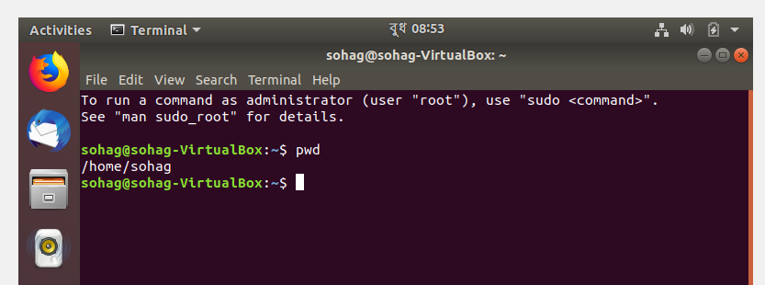

- ls : If we want to know that what files are in directory that we are in. Then we able to see all hidden files using by the command “ls”
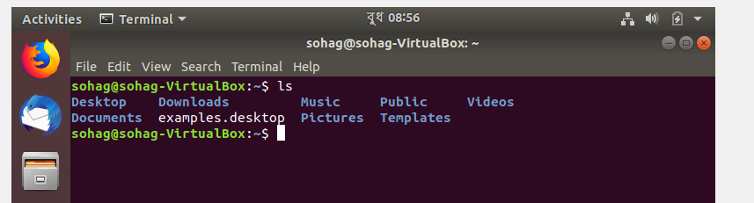
- cat : The cat command is used to display for the contents of file. Normally it is used for view program easily.

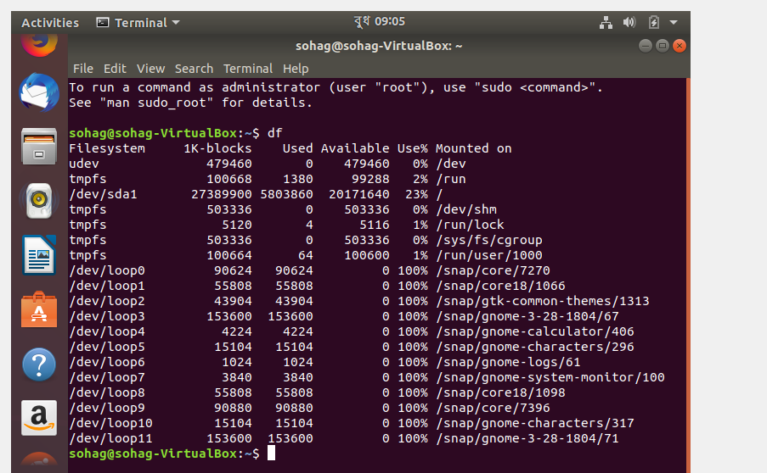
- cd : If we want to go to a new directory then we may use the command of cd. For example if we are in home folder and we want to go to documents folder then we may type “cd documents”
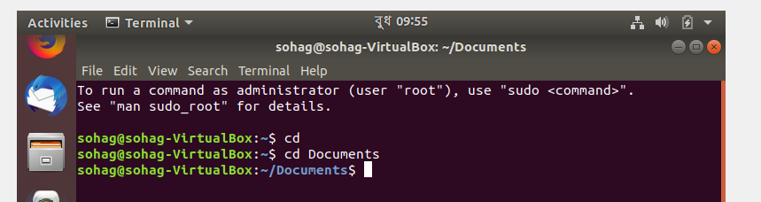

5 . ping : Ping is used to check our pc connection with a server. We are able to confirm that our internet connection is connected or active.

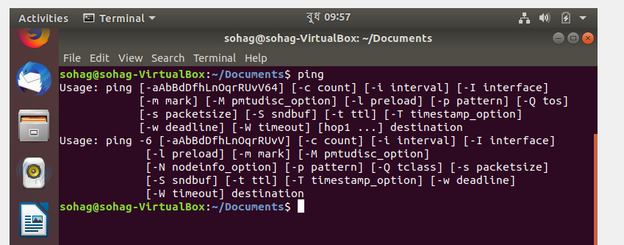

6 . stat command : stat command is used for check the status of a file. This gives us detailed informations about a file .

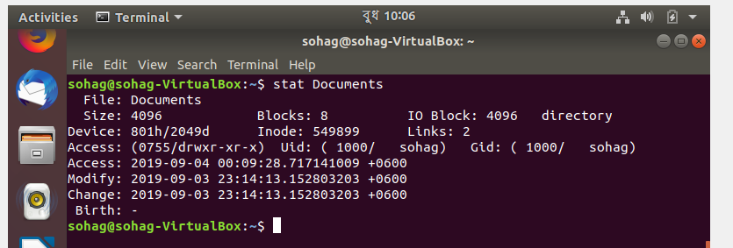

7. head command : “head” command is used to display first few line of any file. Normally it display first 10 line of a file.

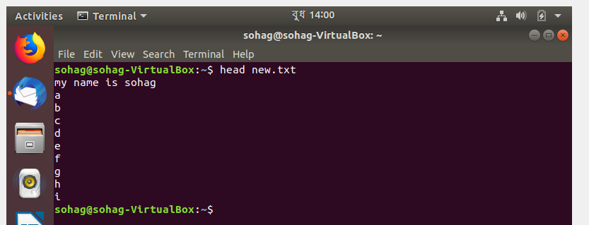

8. tail command : As same as “head” the “tail” command shows last 10 line of a file
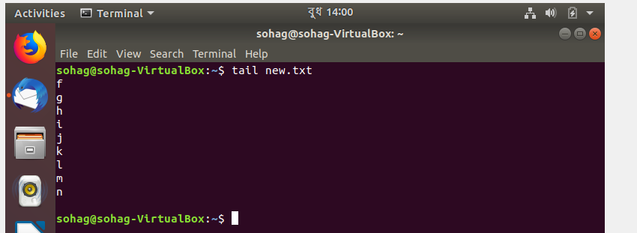

9. wc command : “wc” command is used to count lines, words and letters that will be inputed.
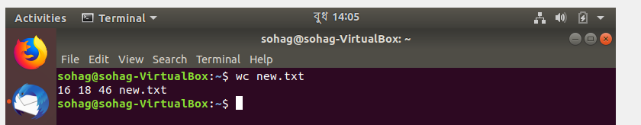

10. grep command : “grep” command is used to search for a pattern in a file.
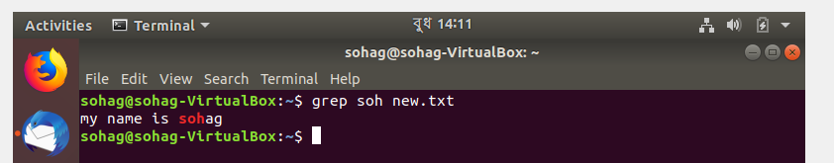

11. w command : “w” command is used for checking which users are already logged in the system and also commands are executing at the particular time.
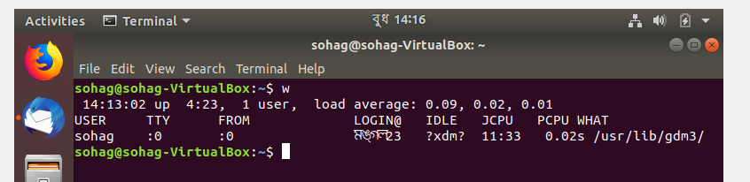

12. last command : “last” command is used to display information about user who logged in and also logged out from the system.

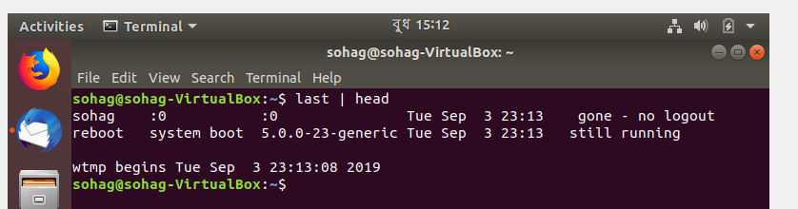

13. du command : “du” command is used to determine disk usage for any file. we can easily know about the usage of memory for a particular file.

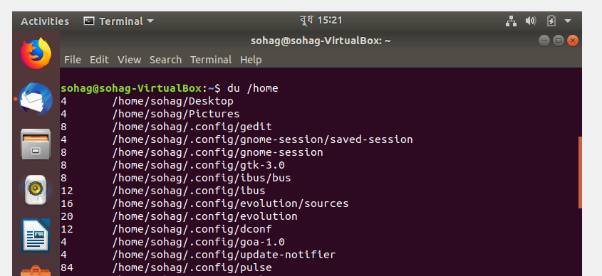

14. df command : “df” command is used for “disk files-system” we come to know summery of free and also used disk memory usage on the file system of linux system.
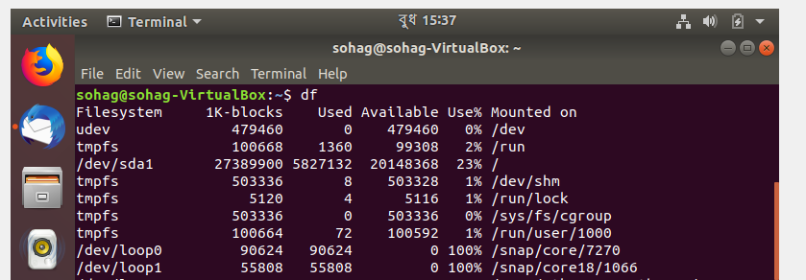

15. history command : “history” command is used to show commands that we have already entered on our terminal so far.

